**Steps to create an EBS Snapshot:**

## Open the Amazon EC2 console at <https://console.aws.amazon.com/ec2/>.

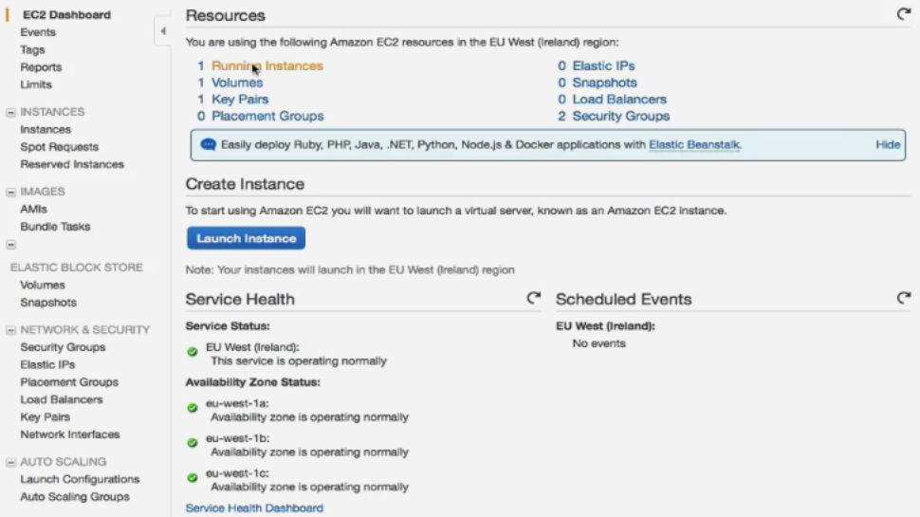

1. There are two ways to create an EBS Snapshot, either go to the Snapshot option directly from the EC2 Dashboard or click on Volumes option there we select a volume to take snapshot then go to action tab then click on Create Snapshot

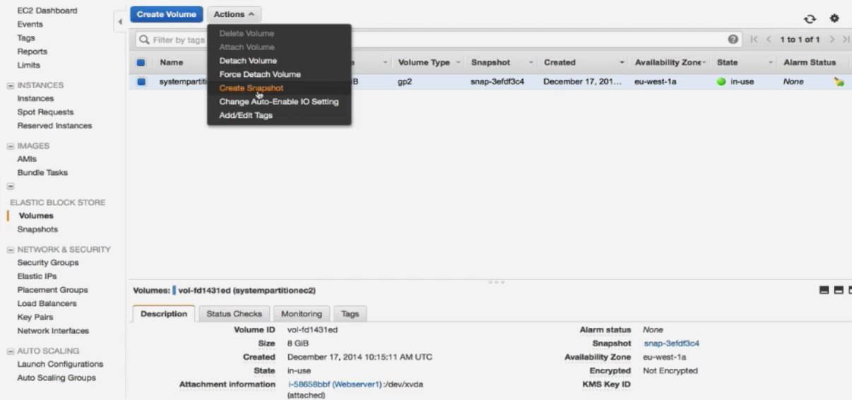

1. The Create Snapshot dialog box appears. There we have to specify name for snapshot and description for it. Then Click **Create**.

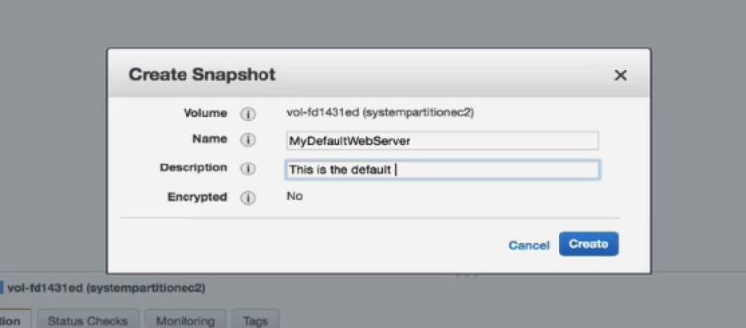

Amazon EC2 begins creating the snapshot.

1. Now let’s check Snapshot created or not by looking in the Snapshot page in the EC2 Dashboard

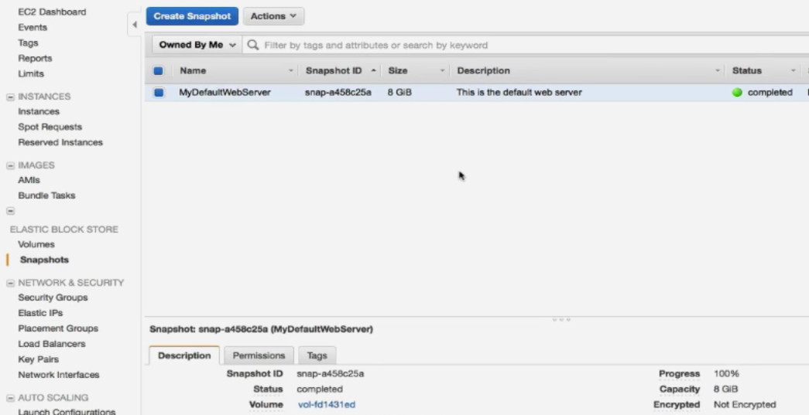

1. Snapshot has been created now to create an AMI select the snapshot then Go to the ‘Actions’ menu and Select ‘Create Image’.

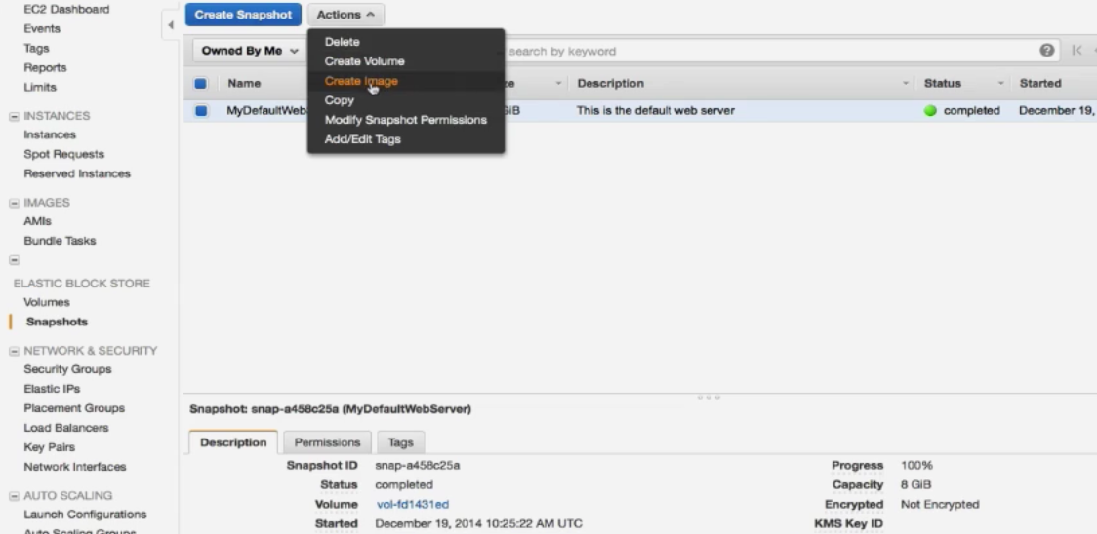

Here we Enter Image Name Few other Required Details and Specifications for image then click on Create.

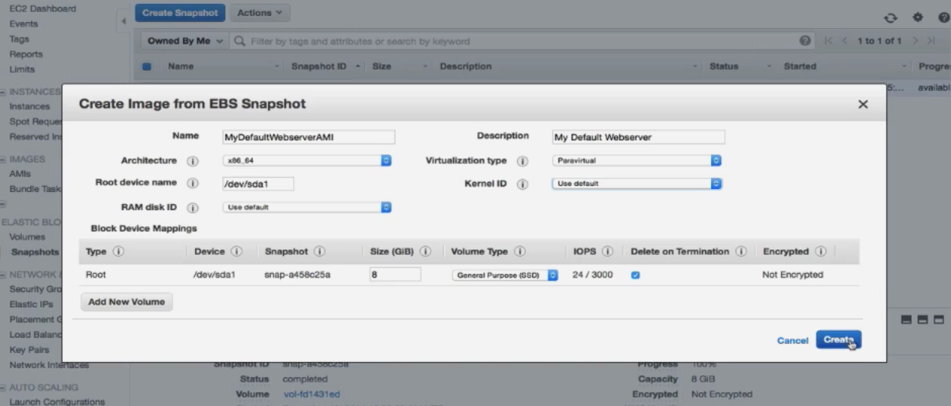

This will begin creating the Snapshot for your EBS Volume.

# When the green button shows 100%, it means snapshot is now created.

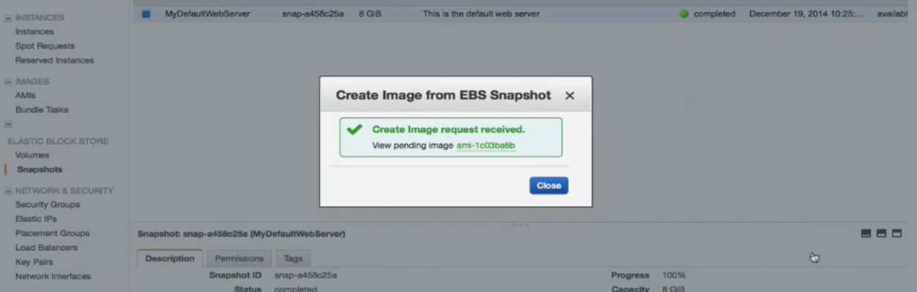

You can also create a copy of this snapshot, delete it and add permissions to it.

1. When an AMI created it is by default Private. To change its Permissions we have go to Action tab there select Modify Image Permissions.

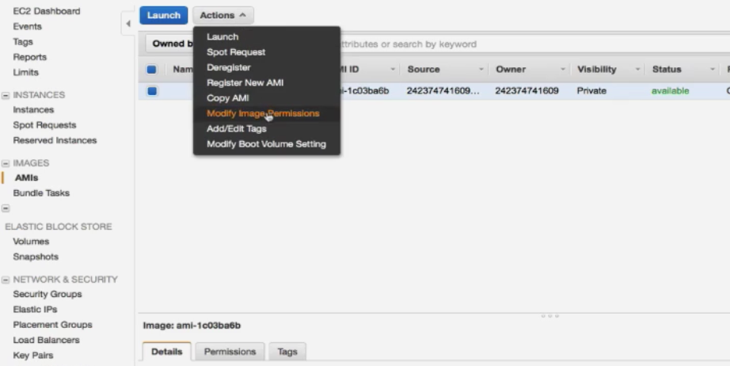

1. Changing Permissions from Private to Public or Add users to access this AMI then Click Save

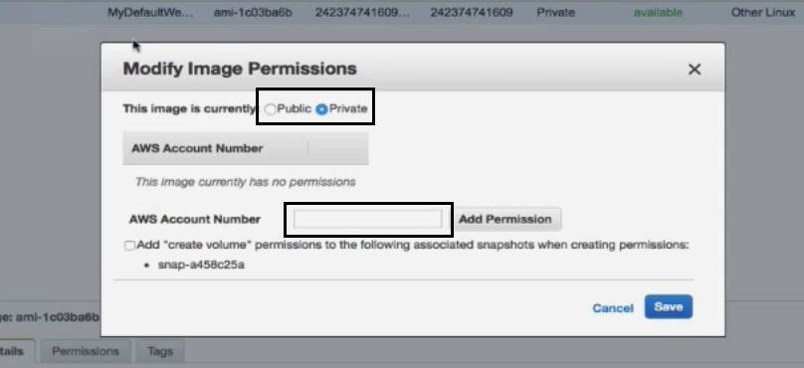

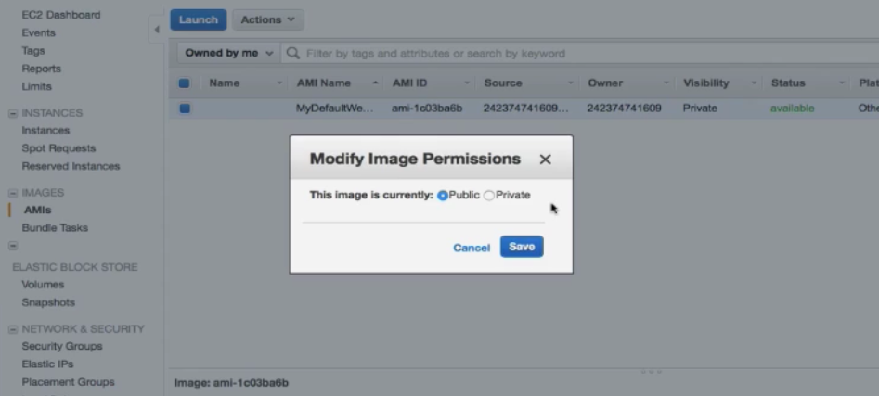

Now Image Ready to Use and Public